Special Topics 2026

 | Project Information
Name |  | Creature Battles
Related Project |  | Super Auto Pets, Pokémon
Project Contributors |  | Bayne Wilson, Jacob Hodges

 | Revision Summary
Date |  | Name | Comments
04-Mar-26 |  | Bayne Wilson | Initial Draft
09-Jun-26 |  | Jacob Hodges | Added Images + Project Description

Table of Contents
1 | Project Description
2 | Project Details
3 | Document Sensitivity
4 | Boneyard

- Project Description
Creature Battler is a mix of Pokémon and Super Auto Pets. We took more inspiration from Super Auto Pets for having a buy stage where you purchase creatures and use them to fight though we took more inspiration from Pokémon for the combat, having creatures with multiple moves to select from to attack other creatures with.
- Project Details
  - Data Models
    - Creature
Stores the creatures stats class. Each creature gets stored in an array in the creatureService class. Each creature is duplicated when a new creature is requested.
    - Ability
Stored as a string. The string gets parsed by the ActionService class. Example “Damage-100|Stun-30”, the vertical bar differentiates which moves the action does, this one would do 100 damage and apply 30 stun stacks.
    - Lobby
Stored as a variable called lobbyState. Stores the players and details about the lobby such as the lobbySettings, id and names. Created by the user.
    - Player
Stores the id of the player and the creatures in addition to the money and ready status of the user. Created when the user joins a lobby.
    - Stats
Stores the permanent and non-permanent details of a creature, stored in the creature model.
    - Scenes
Stores all the scenes of the lobby
- Main Menu
- Lobbying Menu
- Lobby Menu
- Buy Stage
- Battle Stage
- Results Stage
- End Stage
  - Behavioral Details
    - Server Communication
      - When program boots, the client establishes a WebSocket connection with the server.
      - Client to Server Requests
        - CreateLobby
- String playerName
- String lobbyId
Sends a request to the server to create a lobby with lobbyId, this will also make the player with the name and place with playerName them in the lobby as the owner
Fails upon:
- Lobby Already exists with id = lobbyId
        - JoinLobby
- String playerName
- String lobbyId
Sends a request to the server to join a lobby with lobbyId, this will also make the player with playerName and place them in the lobby
Fails upon:
- Lobby already has max players
- Lobby.stage ≠ StageState.LobbyStage
        - StartGame
- String lobbyId
Sends a request to the server to start the lobby with lobbyId. The server gets the requesting player based on the session making the request’s id.
Fails upon:
- Client who made request ≠ owner of the lobby
- Lobby.stage ≠ StageState.LobbyStage
- Lobby not having the proper amount of players
        - ReadyUp
- String lobbyId
Sends a request to the server to ready up the player (obtained through the session.id).
Fails upon:
- Player not being in a lobby
        - BuyCreature
- Creature creature
Sends a request to the server to buy a creature, the client sends a creature that it wants to buy and the server does some checks to make sure the client can buy the creature then give the creature to the player.
Fails upon:
- The client does not have enough money
        - UseAbility
- String abilityId
Parses the abilityId and gets the lobby from the clients id. Gets the client’s id from where the request is coming from. Then enacts the ability in the server.
        - GetCreatureBuyOptions
The client asks for creatureBuyOptions when starting the buyStage.
        - Reroll
The client refreshes the creatureBuyOptions. Costs 30 gold.
Fails when the client doesn’t have enough money.
      - Server to Client Information
        - LobbyJoined
Sent after the client attempts to join an lobby and it succeeds
        - BuyStageStarted
Sent when the lobby enters the buyStage.
        - BattlesStarted
Sent when the lobby enters the battleStage
        - ResultsStageStarted
Sent when the lobby’s battleStage ends
        - CreatureStunned
Sent when a creature gets stunned and loses their turn.
        - CreatureBurned
Sent when a creature starts their turn with a burn stack and takes some damage.
        - CreatureStatusEffectApplied
Sent when a creature receives any status effect. Allows the client to display the information.
        - CreatureBuyOptions
Sent when the client either rerolls their buy options or starts their buy stage.
        - Update
Sent when the server just needs to send a basic update to the client of a new lobbyState.
        - GameOver
Sent when one of the players in the lobby reach 0 lives
  - Visual Features
    - Scene Management
      - Overview
        - Scenes are the current stuff being displayed
        - The scenes will switch based on server requests
        - Each scene has its visuals
          - buttons
- They each have text and then an action on click
          - inputBoxes
- They each have a field which can be read
          - gameObjects
- These are the objects that are changing throughout the scenes life.
        - Scene List
          - Main Menu
Navigation to the lobbying menu, how to play menu or the options menu.
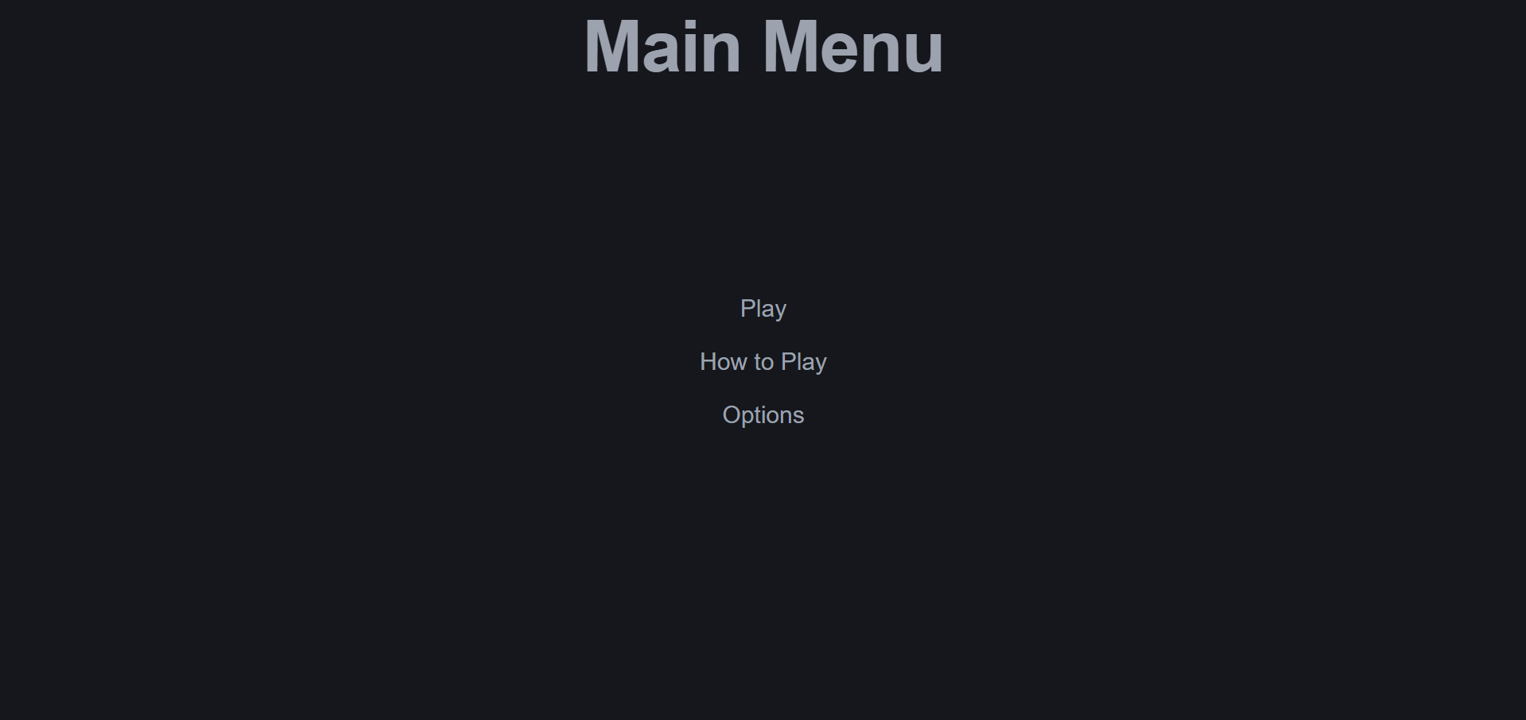
- “Play” -> sends the player to the lobby joining menu
- “How to Play” -> sends the player to a instructions manual screen
- “Options” -> Nothing. (See boneyard)
          - Lobby Finder
Where the user can find and join a lobby to play with. The user enters a lobby id and username, then the user can join or create a lobby.
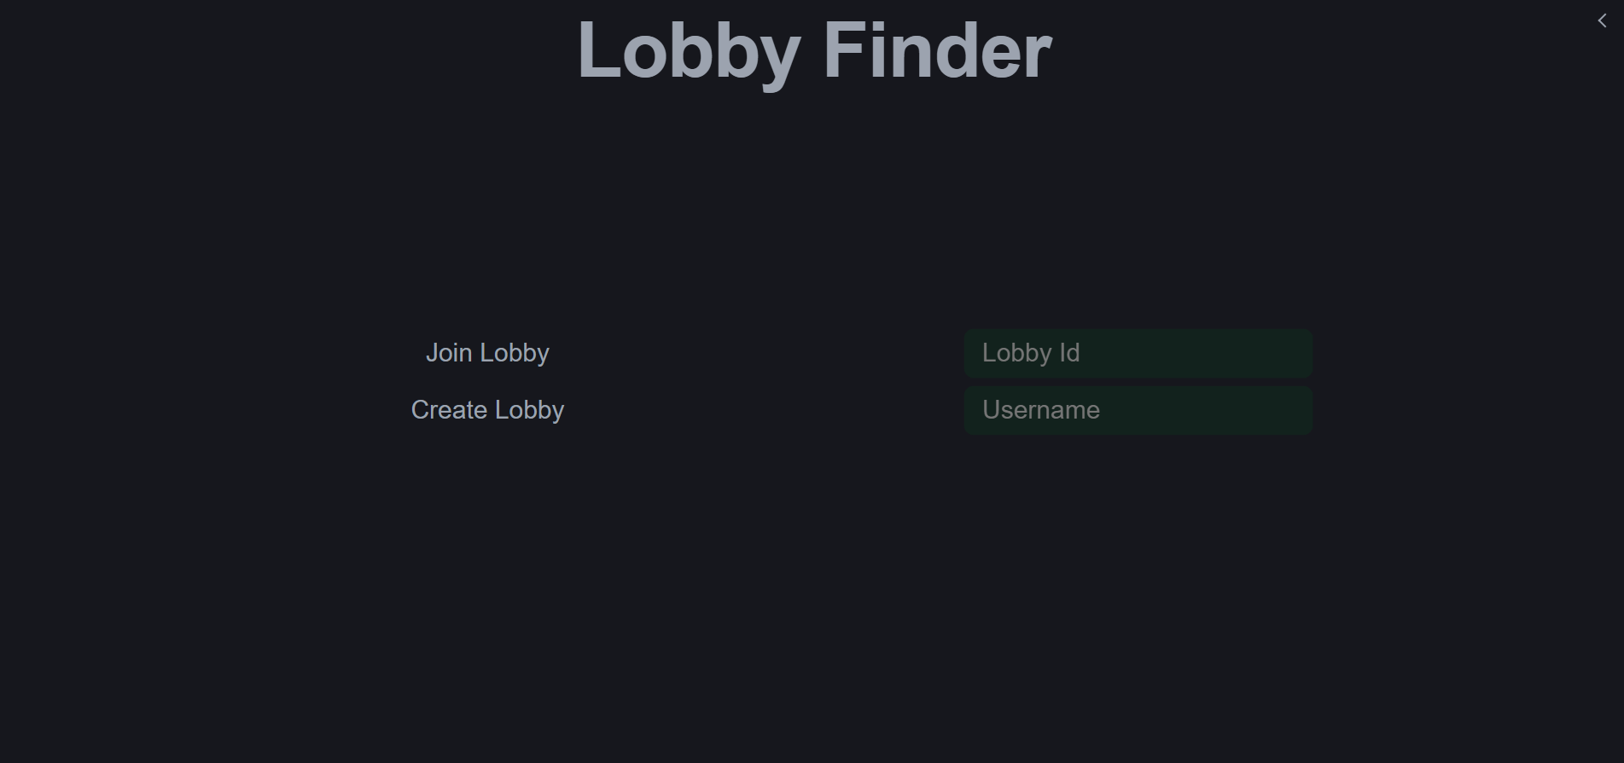
- “Lobby Id” -> Input box for the lobby id. Used when joining or creating a lobby.
- “Username” -> Input box for the username of the user. Used when joining or creating a lobby.
- “Join Lobby” -> Sends a request to the server for the user to join the lobby of desired id.
- “Create Lobby” -> Sends a request to the server for the user to create a lobby of desired id.
          - Lobby
Where the user gets to see the lobby that they are in and the details of that lobby. The owner gets an extra option to begin the game, which will send the clients to the buy menu and begin the game.
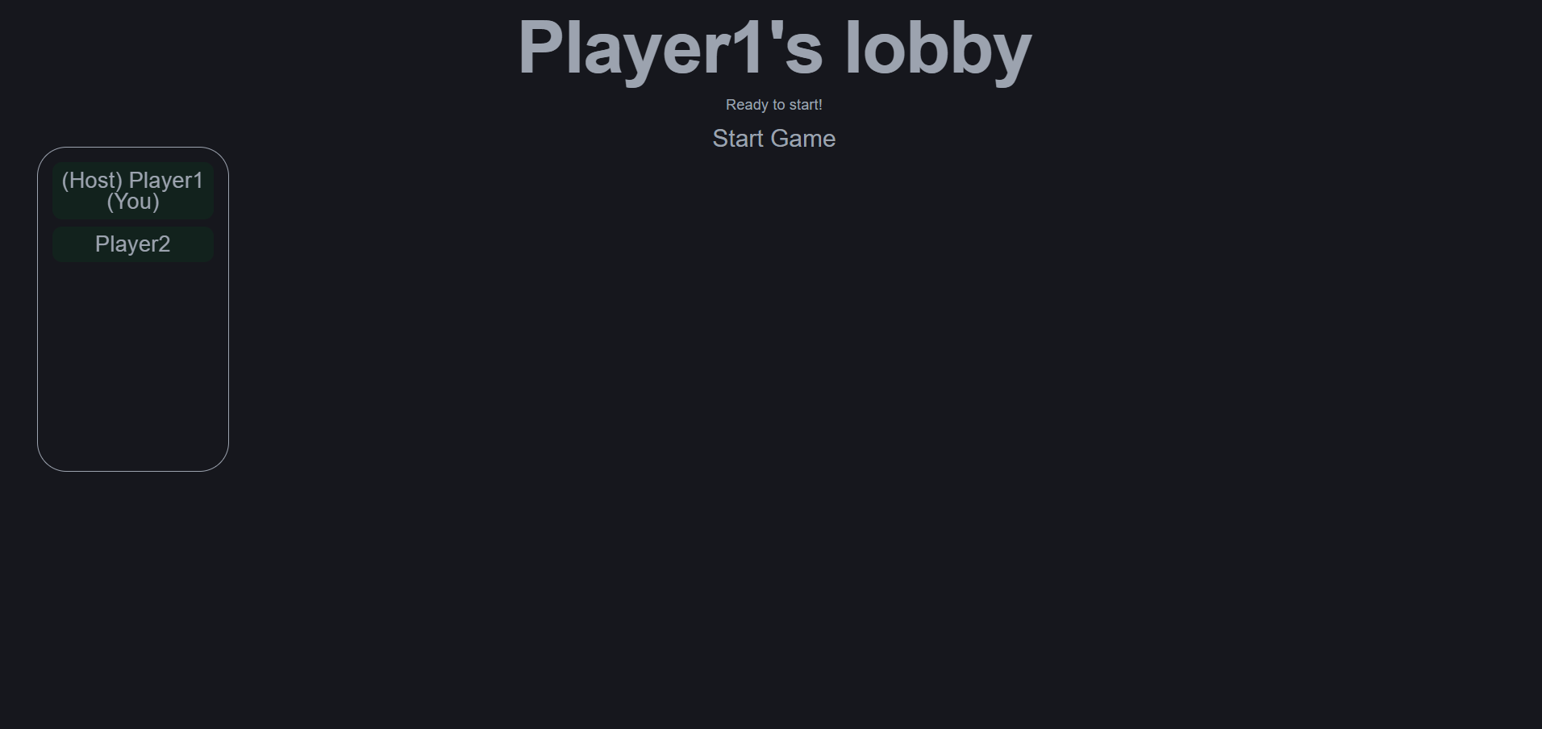
- “Start Game” -> When there is 2 people in a lobby the owner of the lobby gets an option to start the lobby, sending them into the buy stage.
- Box on the left -> Shows the players in the lobby.
          - Buy Stage
Where the user can buy their creatures and gear. The creatures are random and cost money that the user earns from battles. The bottom displays the creatures the player currently owns. The clients can ready up in order for the timer to tick faster and then the lobby will head to the battle stage.
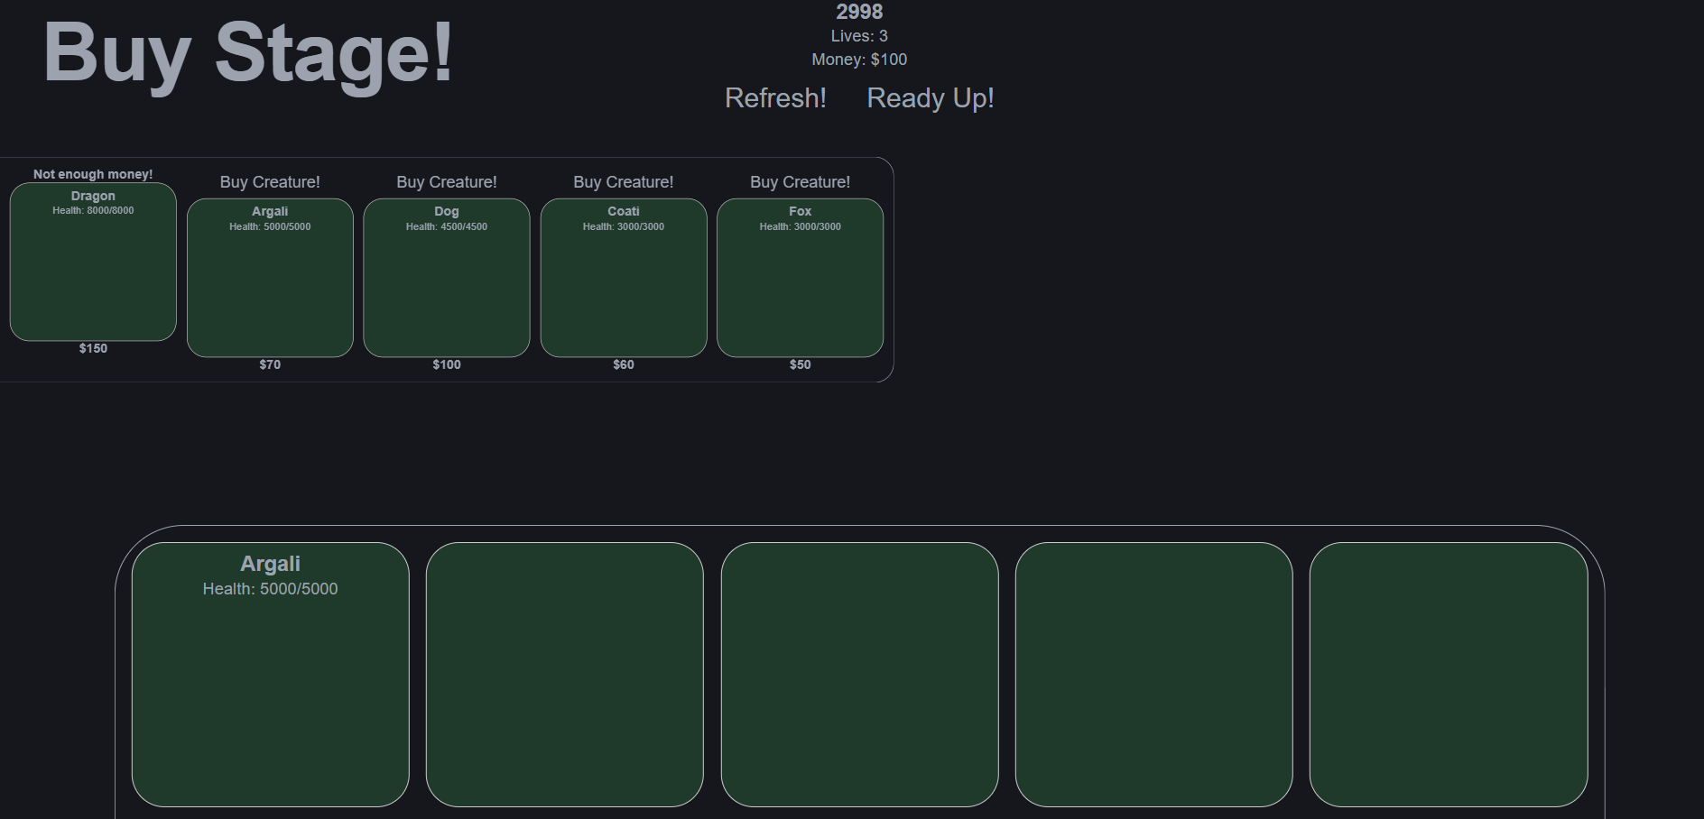
- “Refresh!” -> Sends a request to the server to get a new set of creatures for the user to choose from.
- “Ready Up!” -> Sends a request to the server to show that they are ready for the battle to start.
- Bottom Box -> Displays the creatures that the player currently owns.
- Left Box -> Displays the creatures that the client can choose to buy from.
          - Battle Stage
Where the user battles another user with their creatures. Each client has ability options that do either damage or inflict status effect. When a creature dies a new creature will be subbed in and the battle will continue. Once one player looses all their creatures the lobby will head to the results stage, and the looser will lose a life. But the looser gets extra money.
- 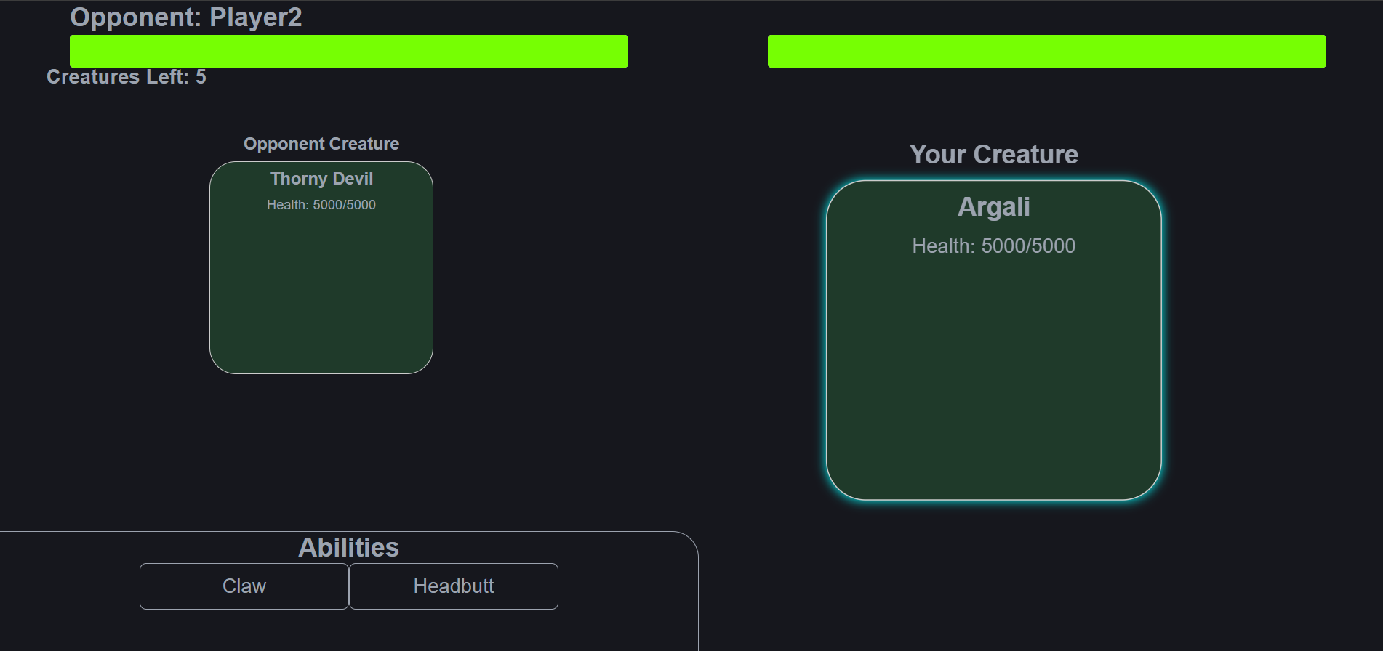
- Abilities Box -> Displays the abilities that the player can use.
- Opponent’s creature -> Displays the creature that is currently active for the opponent.
- Your Creature -> Displays the creature that is currently active for the user.
- The health bars -> Displays how much health is left of each creature.
          - Results Stage
Where the user receives the results of their battle and rewards/penalty. The looser loses a life but gains a bit of extra gold to make sure the already stronger player doesn’t exceed the strength of the looser drastically. The winner earns some gold but not a lot.
- 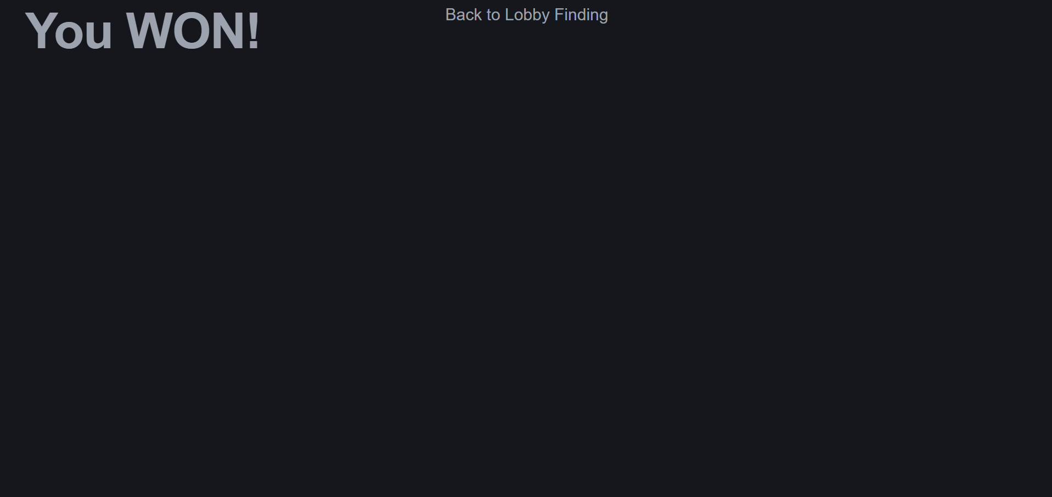
- Top left “You WON!” -> Shows the result for the user of their most recent battle. If the player won, then “You WON!” would be displayed but if the player lost then “You LOST!” would be displayed.
- Boneyard
  - Hover Stats Popup
There was an idea to make it so when the user hovers over the creatures or an ability it shows the details of it such as stats or the story of the creature.
We decided not to do this purely on the aspect of time, we had a somewhat working version of this, but we didn’t push it out because it wasn’t ready.
  - More than 2 people per lobby
We originally planned on after the game got into a more stable spot; we would add a feature so that there could be more than 2 people per lobby.
We didn’t do this because of its low importance; it didn’t seem too useful because not often were there more than 1 person playing the game and so compared to out features it was not important and we never got around to it. The flow of the game also works just fine for 2 people per lobby.
  - Bot Player
We wanted to add a Bot Player to the game and then you could play single player
The Bot Player would make smart decisions with the actions and choose to do things that make sense in terms of the status of the battle
This was something we planned to do but then we got overran with bugs and had to put this to the side.
  - Visuals
We wanted creature and menu sprites. We wanted the sprites to be AI generated.
We attempted to add this and got about half done. The process was long and we almost got around to it by the end of our project but then we needed to do more finishing touches and stuff instead leading to this being pushed to the side.
  - Options Menu
We originally wanted a small options menu to change settings like resolution.
That was diverted when we realized that the switch to React web dev would be necessary. That allowed for dynamic changing of resolution by expanding or shrinking the window. There still would be use of the options menu eventually but with the current project there was not a need for options.

